COLLECTIONS AND DATE ASSIGNMENT

- Write Java code to define List . Insert 5 floating point numbers in List, and using an iterator, find the sum of the numbers in List.
import java.util.ArrayList;
import java.util.Iterator;
import java.util.List;
public class ListExample{
public static void main(String[] args) {
List<Float> list=new ArrayList<>(5);
list.add(1.5f);
list.add(2.5f);
list.add(3.5f);
list.add(6.5f);
list.add(4.5f);
Iterator iterator=list.iterator();
while (iterator.hasNext())
{
System.out.println(iterator.next());
}
}
}
Output:
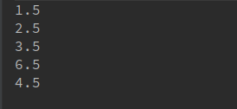

- Write a method that takes a string and returns the number of unique characters in the string.
import java.util.HashSet;
class HashSetExample {
int countCharacters(String string)
{
char ch[]=string.toCharArray();
HashSet<Character> hashSet=new HashSet<>();
for(int i=0;i<ch.length;i++)
{
hashSet.add(ch[i]);
}
return hashSet.size();
}
public static void main(String[] args) {
HashSetExample hashSetExample=new HashSetExample();
int count=hashSetExample.countCharacters("amarjeet malik");
System.out.println("no. of characters in input string= "+count);
}
}
Output:

- Write a method that takes a string and print the number of occurrence of each character characters in the string.
import java.util.*;
class HashMapExample {
void printFrequency(String string)
{
char ch[]=string.toCharArray();
HashMap<Character,Integer> hashMap=new HashMap<>();
for(char c:ch){
if(hashMap.containsKey(c))
hashMap.put(c,hashMap.get(c)+1);
else
hashMap.put(c,1);
}
for(Character o:hashMap.keySet()){
System.out.println(o+" "+hashMap.get(o));
}
}
public static void main(String[] args) {
HashMapExample hashMapExample=new HashMapExample();
hashMapExample.printFrequency("amarjeet");
}
}
Output:
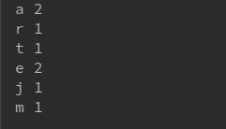

- Write a program to sort Employee objects based on highest salary using Comparator. Employee class{ Double Age; Double Salary; String Name
import java.util.*;
class EmployeeSort {
public static void main(String[] args) {
Employee employee1=new Employee(21,15000,"Amarjeet Malik");
Employee employee2=new Employee(22,16000,"Dolly");
Employee employee3=new Employee(23,14000,"Sumit Singh");
List<Employee> list=new ArrayList<>();
list.add(employee1);
list.add(employee2);
list.add(employee3);
Collections.sort(list, new Comparator<Employee>() {
@Override
public int compare(Employee o1, Employee o2) {
if(o1.age>o2.age)
return 1;
else if(o1.age<o2.age)
return -1;
else
return 0;
}
});
for(Employee e:list)
System.out.println("Employee age= "+e.age+", Employee name= "+e.name+",\tEmployee Salary= "+e.salary);

}
}
class Employee
{
double age;
double salary;
String name;
public Employee(double age, double salary, String name) {
this.age = age;
this.salary = salary;
this.name = name;
}
}
Output:

- Write a program to sort the Student objects based on Score , if the score are same then sort on First Name . Class Student{ String Name; Double Score; Double Age
import java.util.*;
class StudentSort {
public static void main(String[] args) {
Student student1=new Student(21,75,"Amarjeet","malik");
Student student2=new Student(20,69,"Suvreen","duggal");
Student student3=new Student(22,75,"Jaspreet","singh");
List<Student> list=new ArrayList<>();
list.add(student1);
list.add(student2);
list.add(student3);
Collections.sort(list, new Comparator<Student>() {
@Override
public int compare(Student o1, Student o2) {
if(o1.score>o2.score)
return 1;
else if(o1.score<o2.score)
return -1;
else {
return o1.firstName.compareTo(o2.firstName);
}
}
});
for(Student e:list)
System.out.println("Student age= "+e.age+", Student name= "+e.firstName+" "+e.lastName+",\tStudent score= "+e.score);

}
}
class Student
{
double age;
double score;
String firstName;
String lastName;
public Student(double age, double score, String firstName,String lastName) {
this.age = age;
this.score = score;
this.firstName = firstName;
this.lastName= lastName;
}
}
Output:
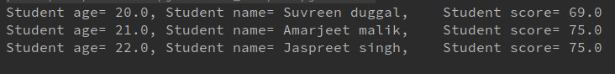

- Print the elements of an array in the decreasing frequency if 2 numbers have same frequency then print the one which came first.
import java.util.LinkedHashMap;
import java.util.Map;
class FrequencySort {
public static void main(String[] args) {
int input[] = {3, 5, 2, 3};
Map<Integer, Integer> map = new LinkedHashMap<Integer, Integer>();
for (int i = 0; i < input.length; i++) {
if (null != map.get(input[i])) {
int k = map.get(input[i]) + 1;
map.put(input[i], k);
} else {
map.put(input[i], 1);
}
}
System.out.println("Elements Frequency");
for (Integer i:map.keySet())
System.out.println(i+"\t\t\t"+map.get(i));
}
}
Output:
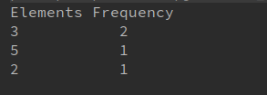

- Design a Data Structure SpecialStack that supports all the stack operations like push(), pop(), isEmpty(), isFull() and an additional operation getMin() which should return minimum element from the SpecialStack. (Expected complexity O(1))

- Write a program to format date as example "21-March-2016"
import java.text.SimpleDateFormat;
import java.util.Date;
class CalenderPractice{
public static void main(String[] args) {
SimpleDateFormat simpleDateFormat = new SimpleDateFormat("dd-MMMMM-yyyy");
Date date = new Date();
System.out.println(simpleDateFormat.format(date));
}
}
Output:
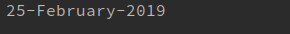

- Write a program to display times in different country format.
import java.text.DateFormat;
import java.util.Date;
import java.util.Locale;
class CalenderPractice{
public static void main(String[] args) {
Date d1 = new Date();
System.out.println("Today is " + d1.toString());
Locale locItalian = new Locale("it", "ch");
DateFormat df = DateFormat.getDateInstance(DateFormat.FULL, locItalian);
System.out.println("today is in Italian Language in Switzerland Format : " + df.format(d1));
}
}
Output:

